SLMHA Coach Evaluation

Team:
Submitted By:
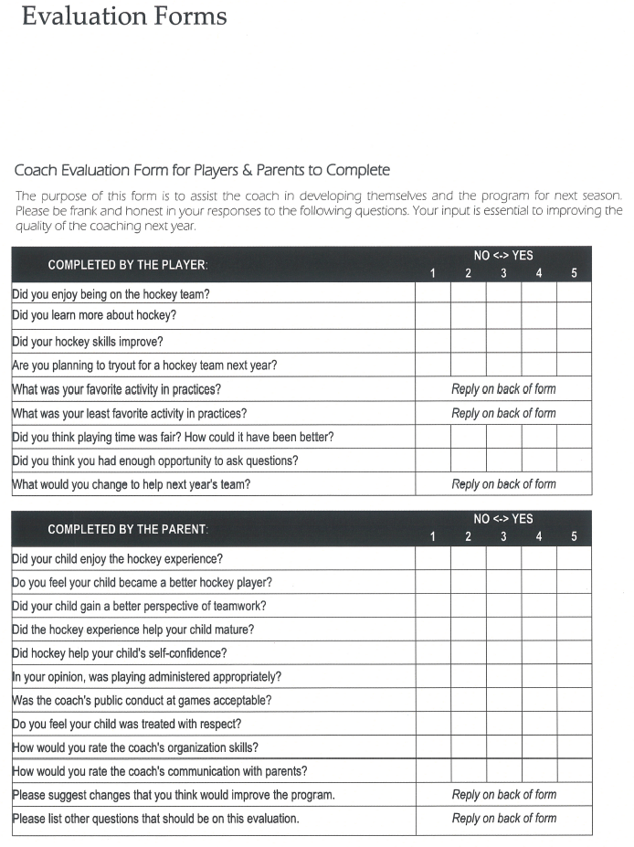

Submit to SLMHA before March 15th, 2015
Lobby Box or Mike Murphy – murphsplace@ametelecom.net

