SLMHA Coach Evaluation

Team:_________________________________________________

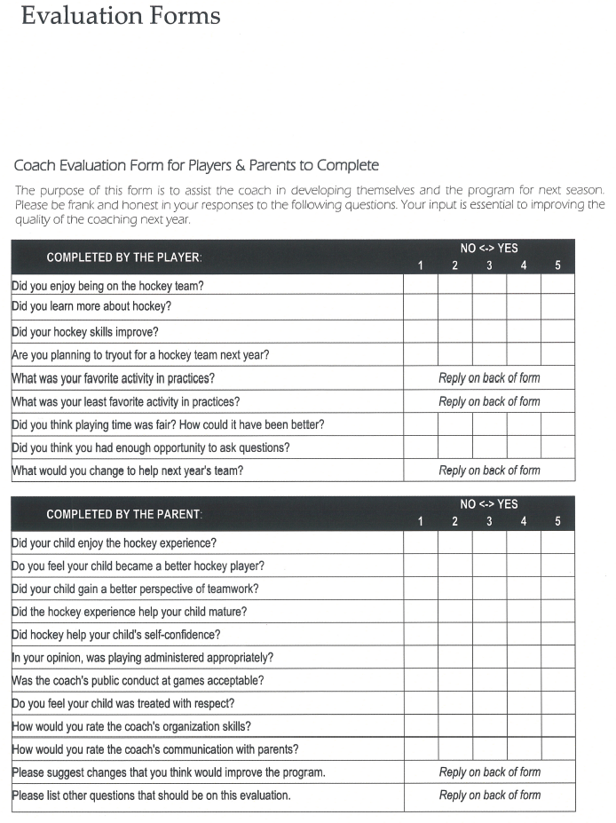
Submitted by:__________________________________________
Submit to SLMHA before March 15th, 2014

Please fill out one of the above and place them in the ballot box located in the Shallow Lake lobby

