SLMHA Coach Evaluation

Team:
Submitted By:
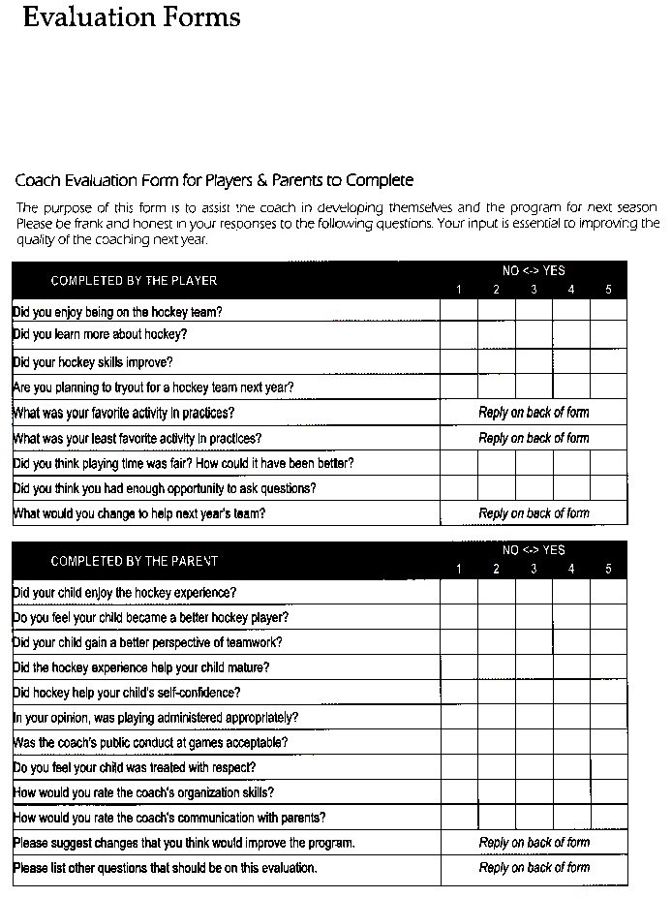

Submit to SLMHA before March 15
Lobby Box or shallowlakehockey@gmail.com

