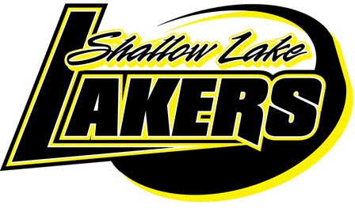
Shallow Lake Minor Hockey Association
Shallow Lake, Ontario
N0H 2K0
shallowlakehockey@yahoo.ca

CODE OF CONDUCT

This Code of Conduct identifies the standard of behavior, which is expected of all SLMHA members, and participants, which includes players, guardians, parents, coaches, trainers, team managers and Executive members.

SLMHA is committed to providing an environment in which all individuals are treated with respect. Members and participants of SLMHA shall conduct themselves at all times in a manner consistent with the values of SLMHA, which includes fairness, integrity and mutual respect.

During the course of all SLMHA activities and events, members shall avoid behavior, which brings SLMHA or the sport of hockey into disrepute, including but not limited to abusive use of alcohol, non-medical drugs and use of alcohol by minors.

Members and participants of SLMHA shall refrain from comments, social media comments or behaviors, which are disrespectful, offensive, abusive, racist or sexist. In particular, behavior, which constitutes harassment or abuse, will not be tolerated, and will be dealt with accordingly.

Failure to comply with this Code of Conduct may result in disciplinary action. Such action may result in the member and participant losing the privileges, which come with SLMHA, including the opportunity to participate in SLMHA activities and events, both present and future.

The Disciplinary Committee that will handle all issues.

I acknowledge that we have read and understand the above Code of Conduct.
It is necessary to sign and return to appropriate Coach before participation in any SLMHA activities. Player and both Guardian/Parents signatures are required.

Player:
 | (Please Print) |  |  | (Please Sign)
Guardian/Parent: (1)
 | (Please Print) |  |  | (Please Sign)
Guardian/Parent: (2)
 | (Please Print) |  |  | (Please Sign)
Date:

